TOPIC 7:TRACTABILITY AND APPROXIMATION ALGORITHM
NAME: LAKSHMI DEVI.J
REG.NO: 192524300
1.Implement a program to verify if a given problem is in class P or NP. Choose a specific decision problem (e.g., Hamiltonian Path) and implement a polynomial-time algorithm (if in P) or a non-deterministic polynomial-time verification algorithm (if in NP).
Aim
To verify whether a Hamiltonian Path exists in a given graph and demonstrate an NP decision problem.
Algorithm
- Start from each vertex.
- Visit every vertex exactly once.
- Check whether consecutive vertices are connected.
- If all vertices are visited, a Hamiltonian path exists.
Python Program
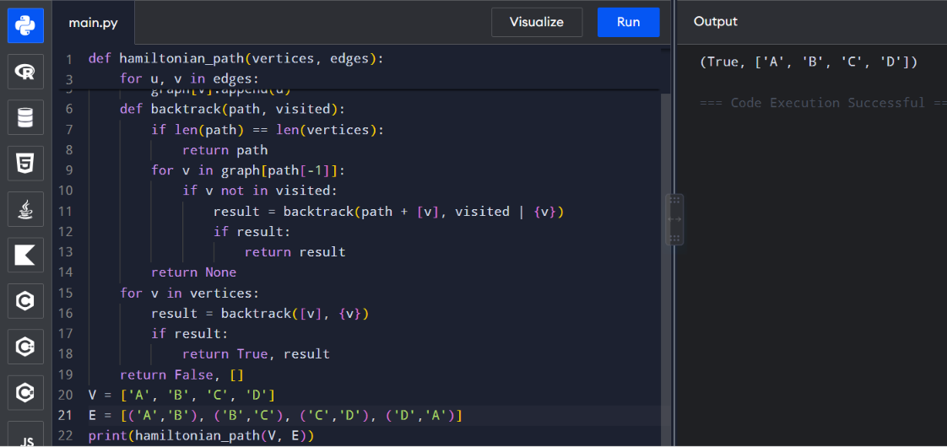
Time: O(n!)
Space: O(n)

2.Implement a solution to the 3-SAT problem and verify its NP-Completeness. Use a known NP-Complete problem (e.g., Vertex Cover) to reduce it to the 3-SAT problem.
Aim
To solve a 3-SAT formula and determine whether a satisfying assignment exists.
Algorithm
- Generate all possible truth assignments.
- Evaluate every clause.
- If all clauses are true, return the assignment.
- If no assignment satisfies all clauses, return False.
Python Program
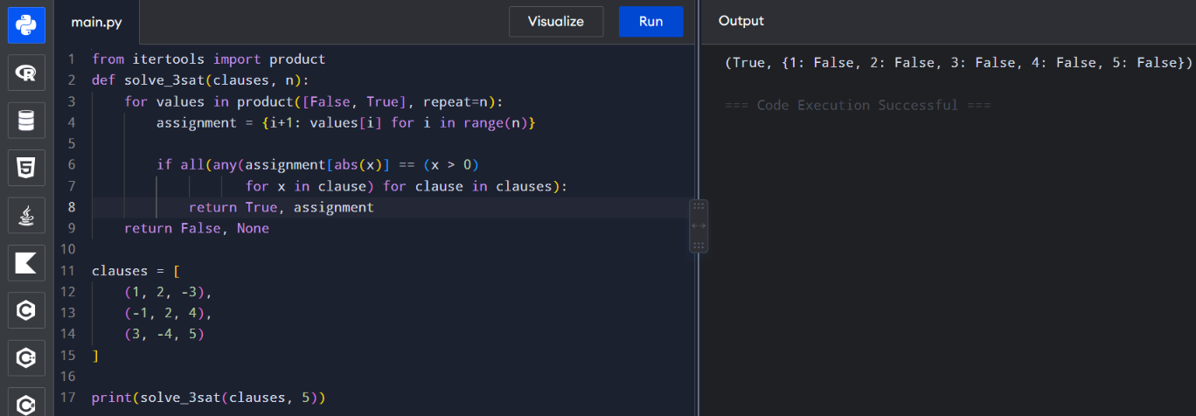
Time: O(2ⁿ × m)
Space: O(n)

3.Implement an approximation algorithm for the Vertex Cover problem. Compare the performance of the approximation algorithm with the exact solution obtained through brute-force. Consider the following graph G=(V,E) where V={1,2,3,4,5} and E={(1,2),(1,3),(2,3),(3,4),(4,5).
Aim
To find an approximate vertex cover and compare it with the exact brute-force solution.
Algorithm
- Select an uncovered edge (u,v).
- Add both u and v to the cover.
- Remove all edges incident to them.
- Repeat until all edges are covered.
- Compare with brute-force optimal solution.
Python Program
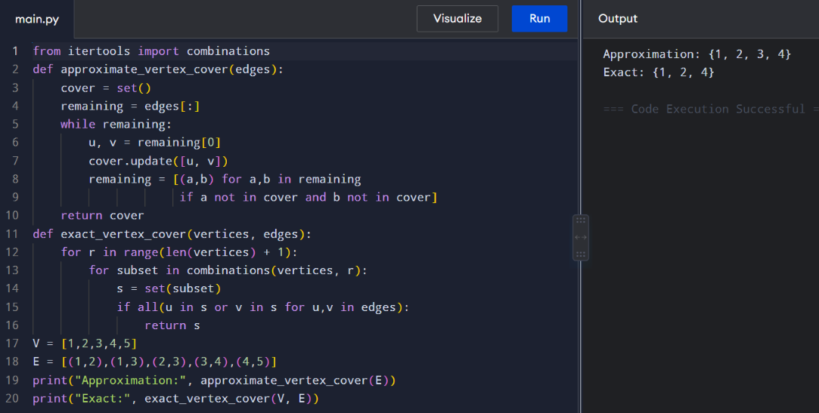
Time: O(V + E) approximately
Space: O(V + E)

4.Implement a greedy approximation algorithm for the Set Cover problem.Analyze its performance on different input sizes and compare it with the optimal solution. Consider the following universe U={1,2,3,4,5,6,7} and sets={{1,2,3}, {2,4}, {3,4,5,6}, {4,5}, {5,6,7}, {6,7}}
Aim
To implement a greedy approximation algorithm for the Set Cover problem.
Algorithm
- Start with an empty cover.
- Select the set covering the maximum number of uncovered elements.
- Add it to the solution.
- Remove covered elements.
- Repeat until the universe is covered.
Python Program
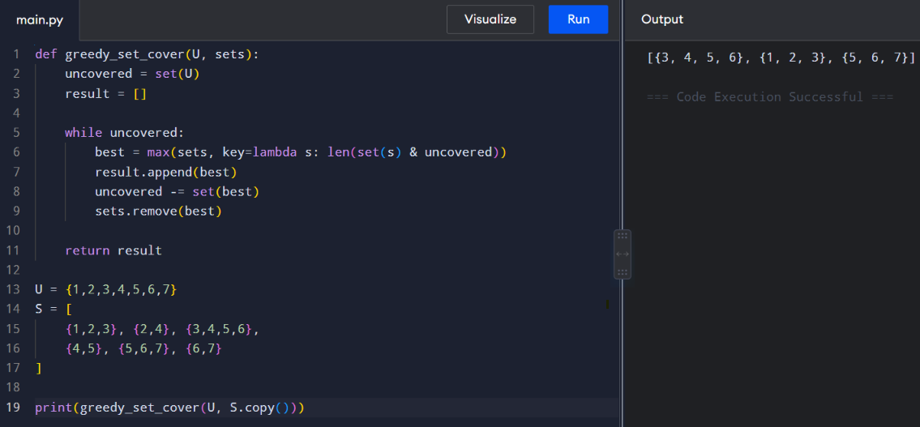
Time: O(S × U) approximately
Space: O(U)
5.Implement a heuristic algorithm (e.g., First-Fit, Best-Fit) for the Bin Packing problem. Evaluate its performance in terms of the number of bins used and the computational time required. Consider a list of item weights {4,8,1,4,2,1}and a bin capacity of 10.
Aim
To implement the First-Fit heuristic for the Bin Packing problem.
Algorithm
- Take each item one by one.
- Place it in the first bin where it fits.
- If it does not fit, create a new bin.
- Count the bins used.
Python Program
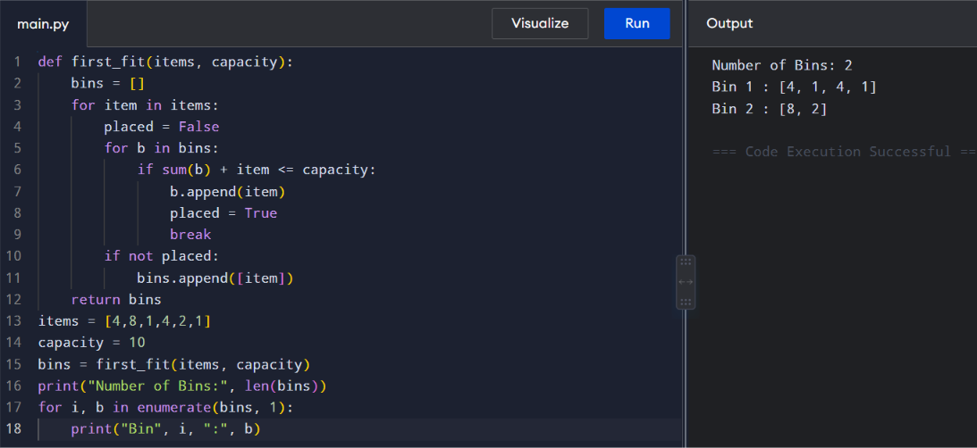
Time: O(n²)
Space: O(n)

6.Implement an approximation algorithm for the Maximum Cut problem using a greedy or randomized approach. Compare the results with the optimal solution obtained through an exhaustive search for small graph instances.
Aim
To find an approximate Maximum Cut using a greedy approach and compare it with exhaustive search.
Algorithm
- Start with two empty sets.
- For each vertex, place it in the set producing the larger cut weight.
- Calculate the greedy cut.
- Enumerate all possible partitions to find the optimal cut.
- Compare both results.
Python Program
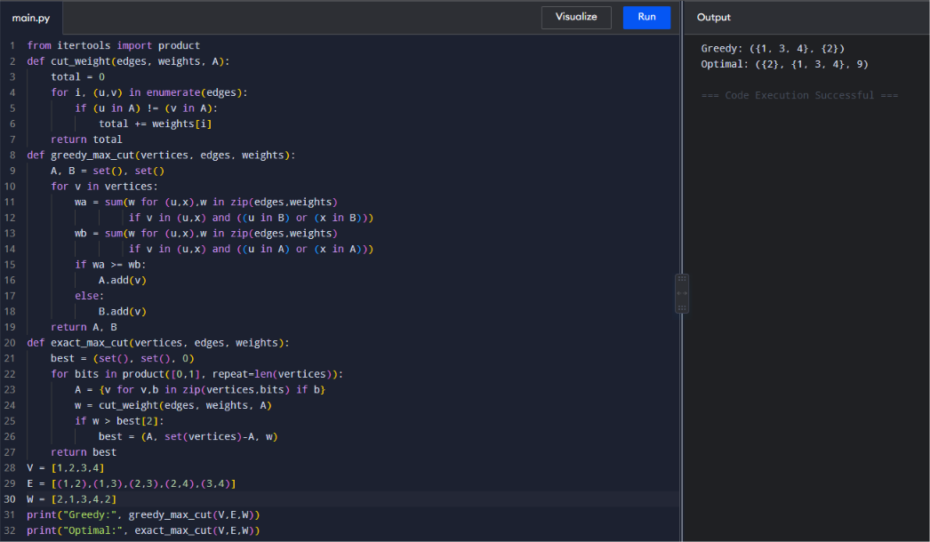
Time – Greedy: O(V + E) approximately
Time – Exhaustive: O(2^V × E)
Space: O(V + E)

